2025 LAGOONFEST ACTIVITY OUTLINE

LagoonFest takes place on Saturday, November 1, 2025, from 9 am to 2 pm
along Flagler Drive in downtown West Palm Beach.

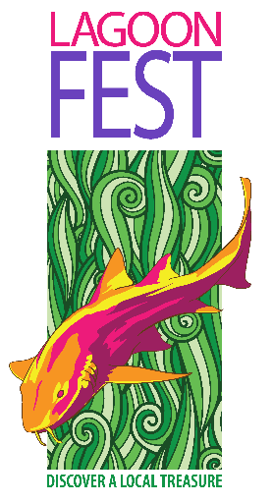
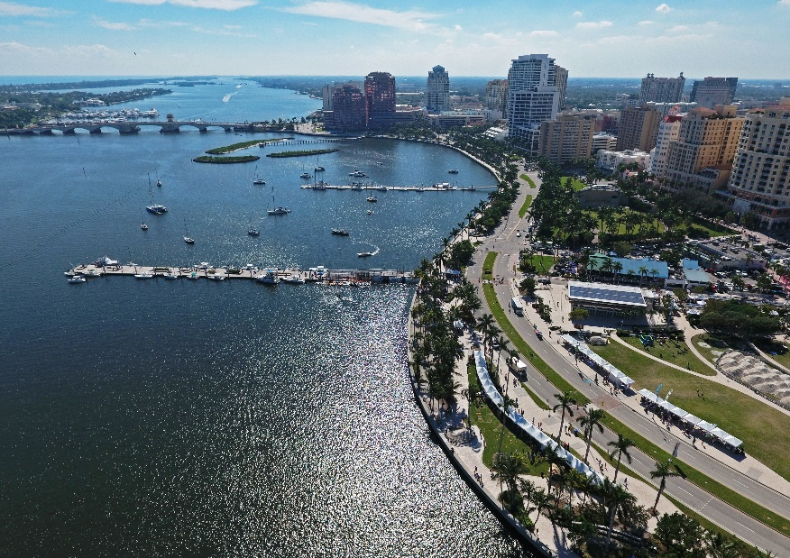

Join us for a Family Fun Day at Lake Worth Lagoon!
Celebrate the beauty and importance of Lake Worth Lagoon with a fun-filled, educational day for all ages. Enjoy wildlife demos, boat tours, clean-up activities, a vibrant Kids Zone, giveaways, and more—plus the West Palm Beach Green Market next door!

Main Attractions

Guided Boat & Kayak Tours – North Dock (Clematis)
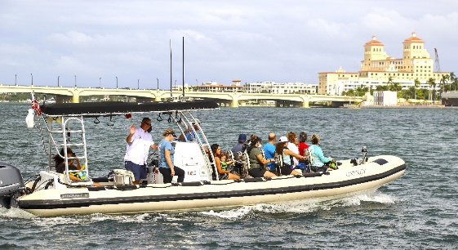
- Aqua Adventure Boat Tour
Times: 9:30 AM, 10:30 AM, 11:30 AM, 12:30 PM
Free guided tour with scientists sharing lagoon history and restoration efforts. First come, first served.

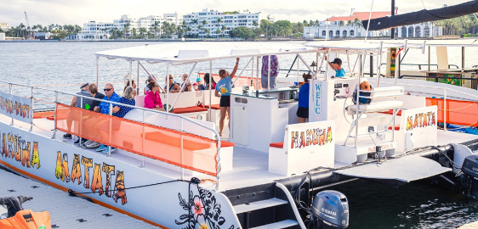
- Hakuna Matata Catamaran Tour
Times: 9:30 AM, 11:00 AM, 12:30 PM
45-minute guided tour aboard a 50' catamaran. $10 Adults / FREE Kids under 12 or Students with ID.
Register in advance

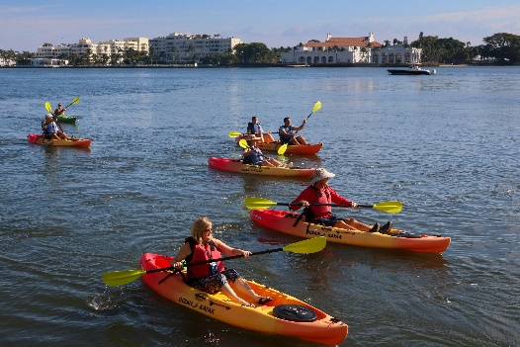
- Kayak Clean-Up Tours
Times: 9:00 AM, 10:30 AM, 12:00 PM
Paddle around South Cove, pick up litter, and learn about lagoon conservation. Equipment provided.
Register here

Kids Zone (Sponsored by Marine Industries Association)


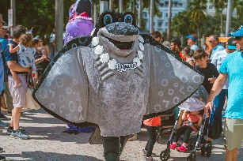
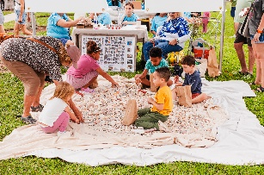
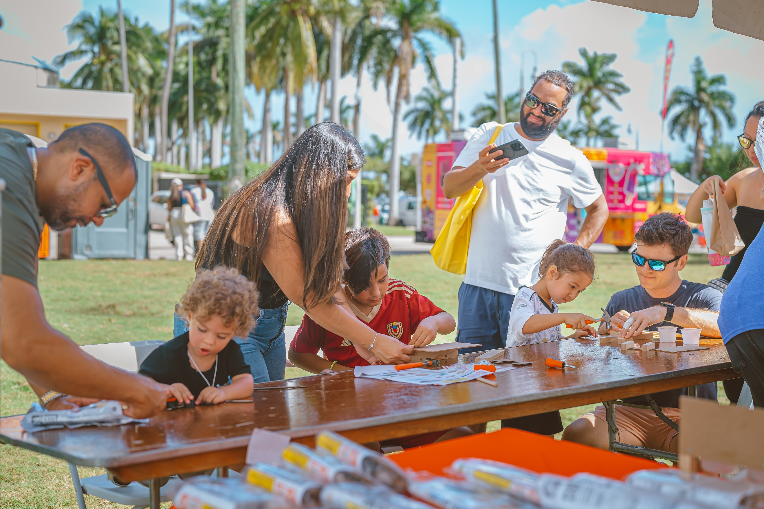
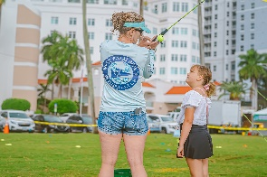
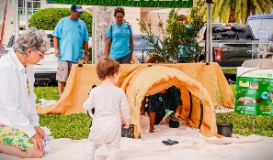
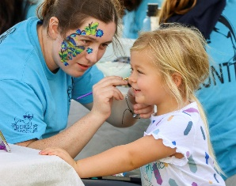
Free and packed with activities:

- Face painting
- Gopher tortoise burrow
- Kids casting challenge (win a rod & reel!)
- Shell hunt
- Mascot parade & photo ops
- Lawn games, crafts, and more

Feature Exhibits & Booths
- ANGARI Foundation (South Dock):
Board a research vessel, explore shark science, and join Lagoon Drift citizen science.
- Busch Wildlife Sanctuary:
Live rehabilitated bird release and native wildlife education.
- Palm Beach County ERM:
Learn how restoration islands are built and their environmental impact.
- FWC (Florida Fish & Wildlife Conservation):
Touch tanks, manatee rescue info, and conservation games.
- Loggerhead Marinelife Center:
Sea turtle VR “Rescue to Release” tour and conservation tips.
- Marine Megafauna Foundation:
Manta ray research games, books, and merch.
- Inwater Research Group:
Sea turtle education, hands-on activities, and merch sales.
- Ocean Rescue:
Safety demos, lifeguard gear, and water knowledge games.
- Coast Guard Auxiliary (Flotilla 54):
Marine safety info, pollution game, and youth giveaways.
- Palm Beach Sailing Club:
Free 30-minute sailing trips on J22 Keelboat. First come, first served.
- City of West Palm Beach – Sustainability:
Tree giveaway for WPB residents/businesses. Register here
- Pollinator Plant Giveaway:
Free native plants, while supplies last. Support pollinators and local biodiversity.
- Manatee Exhibit:
Take a photo with “HOPE” the inflatable manatee. Learn, play, and explore Adopt-a-Manatee®.
- Okeeheelee Nature Center:
Meet animal ambassadors and discover nature centers and parks. Giveaways included.
- Youth Environmental Alliance:
Eco-activities, pollution ID games, and fun with Petey the Pelican.

Event Schedule Highlights
(Subject to change with weather)
- 9:00 AM – 2:00 PM:
Angari Vessel Tours & Sailing Club Lessons
- Mascot Appearances:
9:30 AM – Parade along Flagler
11:00 AM – Kids Zone Walkabout
12:15 PM – Parade
12:30 PM – Bird Release & Calendar Giveaway with Steering Committee and Mascots

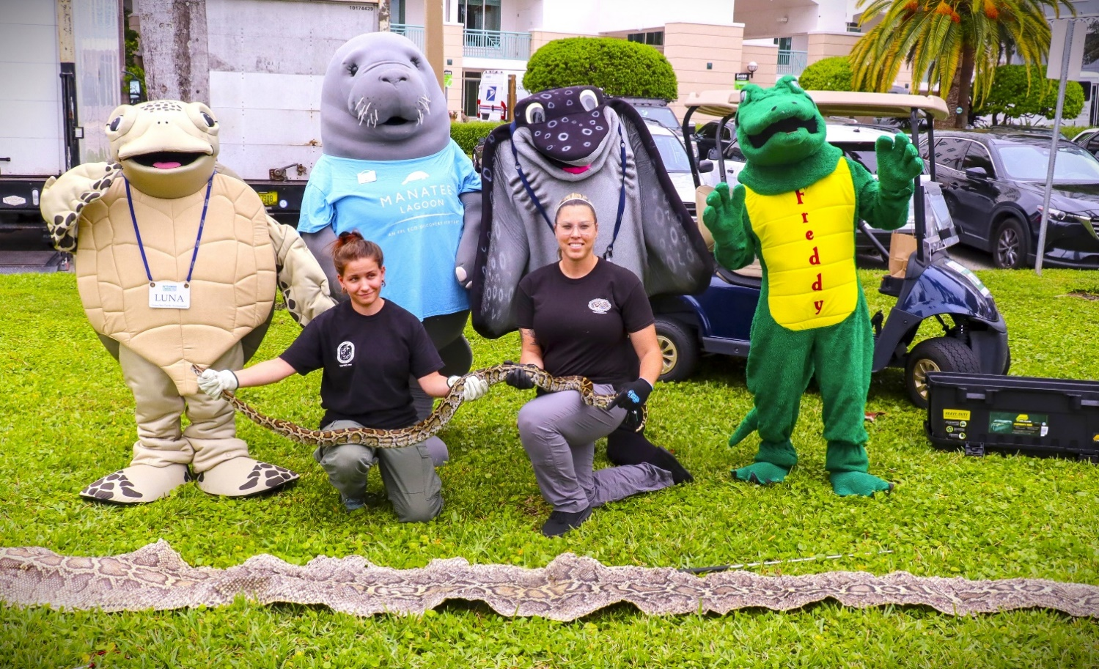

PAST YEARS EXHIBITOR PHOTOS

